**DataSense AI**

***Unlocking the story behind your data***

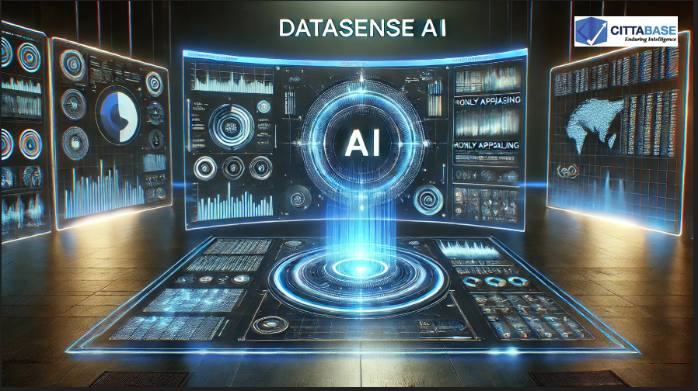

*Cittabase DataSense AI is a Snowflake Native App that leverages the power of Large Language Models (LLMs) to automatically generate intelligent metadata and high-level insights for any table in your Snowflake environment. Simply provide the database, schema, and table name, and DataSense AI. It will generate the following.*

*✅ Data Preview & EDA – Preview your data and plot Univariate and Bivariate charts.*

*✅ Observations on Fields – Identify meaningful information about key fields.   
✅ Anomalies – Identify any outliers and inconsistencies   
✅ Key Factors – Any other relevant information regarding the data*

*Designed for business analysts, data engineers, and governance teams, DataSense AI accelerates data understanding and insight generation—empowering organizations to make informed decisions faster within the Snowflake Data Cloud.*

***Please Note:***

* *DataSense AI utilizes gemma-7b LLM within Snowflake, and would consume Snowflake credits. Please refer to the official* [*Snowflake Credit Consumption Table*](https://www.snowflake.com/legal-files/CreditConsumptionTable.pdf) *for detailed credit consumption.*
* *If Cortex LLM functions are not enabled, you could consider enabling cross region inference by referring the below link,*[***https://docs.snowflake.com/en/user-guide/snowflake-cortex/cross-region-inference***](https://docs.snowflake.com/en/user-guide/snowflake-cortex/cross-region-inference)***.*** *This enables inference requests to be processed from a different region where LLMs are available. Please note that you will be charged credits for the use of LLM as described in detail in the above link. Please review the same. Credits are considered consumed in the requesting region.*

* *This application leverages LLM models, which may exhibit biases and potential inaccuracies based on the data they were trained on. While every effort is made to provide accurate and unbiased insights, the generated descriptions and summaries should be reviewed and validated.*

**LLM Usage:** If Cortex LLMs are not enabled in your region, you could consider enabling cross region inference by referring the below link,  
<https://docs.snowflake.com/en/user-guide/snowflake-cortex/cross-region-inference>

This enables inference requests to be processed from a different region where LLMs are available. **Please note that you will be charged credits for the use of LLM as described in detail in the above link. Please review the same. Credits are considered consumed in the requesting region.**

**Please note that the app also requires IMPORTED PRIVILEGES ON SNOWFLAKE DB.** If the privilege is not currently in place, you will see the popup as shown below:

Upon clicking ***‘Grant Privileges’’***, the grants are executed, and the app should function.

**Please ensure that privileges are granted to the desired tables before proceeding, to avoid the app from throwing errors. The grant scripts are provided in the home screen and referenced below as well.**

USE ROLE ACCOUNTADMIN;  
  GRANT USAGE ON DATABASE <DATABASE NAME> TO APPLICATION DATASENSE;  
  GRANT USAGE ON SCHEMA <DATABASE NAME>.<SCHEMA NAME> TO APPLICATION DATASENSE;  
  GRANT SELECT ON TABLE <DATABASE NAME>.<SCHEMA NAME>.<TABLE_NAME> TO APPLICATION DATASENSE;

**Data Preview and EDA:**

This screen provides a preview of the available tables and performs EDA on the selected table.

Follow the instructions given at the beginning to load and give necessary privileges to your table before choosing it from dropdown.

Use the dropdown menu to select and view the desired table.

Depending on the type of variables chosen, the tool will automatically plot the respective EDA.

The EDA for the selected table can be displayed under two check boxes - ***Univariate Graph*** and ***Bivariate Graph.***

**Univariate Graph:**

It has a dropdown which consists of the columns from selected table. Upon selecting the column, a visual appears with a plot of the column.

**Bivariate Graph:**

Unlike the Univariate Graph, it has two dropdowns containing columns from the chosen table. Upon selecting the columns, a visual appears representing the bi-variate graph.

A sample representative chart is shown below:

**Generate Summary:**

This option leverages Large Language Models (LLMs) to generate intelligent metadata and high-level insights for any table in your Snowflake environment. Simply provide the database, schema, and table name, and DataSense AI will analyze your data to identify key observations on fields, highlight important factors, and detect anomalies. This enables deeper data understanding and faster decision-making.

**Note:** If Cortex LLMs are not enabled in your region, you could consider enabling cross region inference by referring the below link,  
<https://docs.snowflake.com/en/user-guide/snowflake-cortex/cross-region-inference>

This enables inference requests to be processed from a different region where LLMs are available. **Please note that you will be charged credits for the use of LLM as described in detail in the above link. Please review the same. Credits are considered consumed in the requesting region.**